***University Physics Volume I***

**Unit 1: Mechanics**

**Chapter 4: Motion in Two and Three Dimensions**

**Conceptual Questions**

1. What form does the trajectory of a particle have if the distance from any point *A* to point *B* is equal to the magnitude of the displacement from *A* to *B*?

Solution

straight line

1. Give an example of a trajectory in two or three dimensions caused by independent perpendicular motions.

Solution

driving due north and the curvature and rotation of the Earth as separate perpendicular motions causing a three-dimensional trajectory, rowing a boat across a lake with a wind perpendicular to the path

1. If the instantaneous velocity is zero, what can be said about the slope of the position function?

Solution

The slope must be zero because the velocity vector is tangent to the graph of the position function.

1. If the position function of a particle is a linear function of time, what can be said about its acceleration?

Solution

The acceleration is zero, because the second derivative is zero.

1. If an object has a constant *x*-component of the velocity and suddenly experiences an acceleration in the *y* direction, does the *x-*component of its velocity change?

Solution

No, motions in perpendicular directions are independent.

1. If an object has a constant *x-*component of velocity and suddenly experiences an acceleration at an angle of  in the *x* direction, does the *x-*component of velocity change?

Solution

Yes, because there is a component of acceleration in the *x* direction.

1. Answer the following questions for projectile motion on level ground assuming negligible air resistance, with the initial angle being neither  nor  (a) Is the velocity ever zero? (b) When is the velocity a minimum? A maximum? (c) Can the velocity ever be the same as the initial velocity at a time other than at *t* = 0? (d) Can the speed ever be the same as the initial speed at a time other than at *t* = 0?

Solution

a. no; b. minimum at apex of trajectory and maximum at launch and impact; c. no, velocity is a vector; d. yes, where it lands

1. Answer the following questions for projectile motion on level ground assuming negligible air resistance, with the initial angle being neither  nor  (a) Is the acceleration ever zero? (b) Is the vector v ever parallel or antiparallel to the vector a? (c) Is the vector v ever perpendicular to the vector a? If so, where is this located?

Solution

a. no; b. no; c. yes, at the peak or top of the launch

1. A dime is placed at the edge of a table so it hangs over slightly. A quarter is slid horizontally on the table surface perpendicular to the edge and hits the dime head on. Which coin hits the ground first?

Solution

They both hit the ground at the same time.

1. Can centripetal acceleration change the speed of a particle undergoing circular motion?

Solution

no

1. Can tangential acceleration change the speed of a particle undergoing circular motion?

Solution

yes

1. What frame or frames of reference do you use instinctively when driving a car? When flying in a commercial jet?

Solution

Earth and the jet

1. A basketball player dribbling down the court usually keeps his eyes fixed on the players around him. He is moving fast. Why doesn’t he need to keep his eyes on the ball?

Solution

If he is going to pass the ball to another player, he needs to keep his eyes on the reference frame in which the other players on the team are located.

1. If someone is riding in the back of a pickup truck and throws a softball straight backward, is it possible for the ball to fall straight down as viewed by a person standing at the side of the road? Under what condition would this occur? How would the motion of the ball appear to the person who threw it?

Solution

The ball will fall straight down, as viewed by a person standing at the side of the road, if the ball is thrown at the speed of the truck. The ball appears to fall straight down as viewed by the person who threw it.

1. The hat of a jogger running at constant velocity falls off the back of his head. Draw a sketch showing the path of the hat in the jogger’s frame of reference. Draw its path as viewed by a stationary observer. Neglect air resistance.

Solution

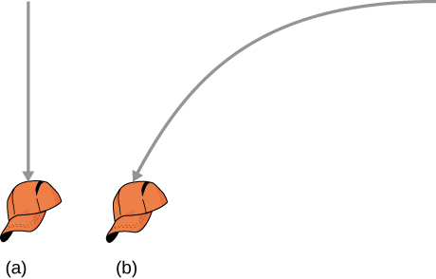

1. A clod of dirt falls from the bed of a moving truck. It strikes the ground directly below the end of the truck. (a) What is the direction of its velocity relative to the truck just before it hits? (b) Is this the same as the direction of its velocity relative to ground just before it hits? Explain your answers.

Solution

a. straight down as seen in the frame of the truck, b. no, relative to the ground it hits at an angle in the frame of Earth

**Problems**

1. The coordinates of a particle in a rectangular coordinate system are (1.0, –4.0, 6.0). What is the position vector of the particle?

Solution



1. The position of a particle changes from  to  What is the particle’s displacement?

Solution



1. The 18th hole at Pebble Beach Golf Course is a dogleg to the left of length 496.0 m. The fairway off the tee is taken to be the *x* direction. A golfer hits his tee shot a distance of 300.0 m, corresponding to a displacement  and hits his second shot 189.0 m with a displacement  What is the final displacement of the golf ball from where it started?

Solution



1. A bird flies straight northeast a distance of 95.0 km for 3.0 h. With the *x*-axis due east and the *y*-axis due north, what is the displacement in unit vector notation for the bird? What is the average velocity for the trip?

Solution



1. A cyclist rides 5.0 km due east, then 10.0 km  west of north. From this point she rides 8.0 km due west. What is the final displacement from where the cyclist started?

Solution

Sum of displacements = 



1. New York Rangers defenseman Daniel Girardi stands at the goal and passes a hockey puck 20 m and  from straight down the ice to left wing Chris Kreider waiting at the blue line. Kreider waits for Girardi to reach the blue line and passes the puck directly across the ice to him 10 m away. What is the final displacement of the puck? See the following figure.

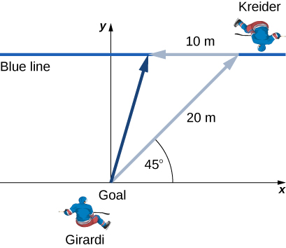

Solution





1. The position of a particle is  (a) What is the velocity of the particle at 0 s and at  s? (b) What is the average velocity between 0 s and  s?

Solution

a. , b. 

1. Clay Matthews, a linebacker for the Green Bay Packers, can reach a speed of 10.0 m/s. At the start of a play, Matthews runs downfield at  with respect to the 50-yard line and covers 8.0 m in 1 s. He then runs straight down the field at  with respect to the 50-yard line for 12 m, with an elapsed time of 1.2 s. (a) What is Matthews’ final displacement from the start of the play? (b) What is his average velocity?

Solution

a. Let *x* be along the 50-yard line and *y* down the field: 

 ,

b.

This is 8.4 m/s at  with respect to the 50-yard line.

1. The F-35B Lighting II is a short-takeoff and vertical landing fighter jet. If it does a vertical takeoff to 20.00-m height above the ground and then follows a flight path angled at with respect to the ground for 20.00 km, what is the final displacement?

Solution







1. The position of a particle is  (a) Determine its velocity and acceleration as functions of time. (b) What are its velocity and acceleration at time *t* = 0?

Solution

a.  ,

b. 

1. A particle’s acceleration is  At *t* = 0, its position and velocity are zero. (a) What are the particle’s position and velocity as functions of time? (b) Find the equation of the path of the particle. Draw the *x-* and *y-*axes and sketch the trajectory of the particle.

Solution

a.  , b. 

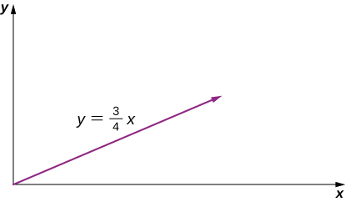

1. A boat leaves the dock at *t* = 0 and heads out into a lake with an acceleration of  A strong wind is pushing the boat, giving it an additional velocity of  (a) What is the velocity of the boat at *t* = 10 s? (b) What is the position of the boat at *t* = 10s? Draw a sketch of the boat’s trajectory and position at *t* = 10 s, showing the *x-* and *y*-axes.

Solution

a.  

  , b.  





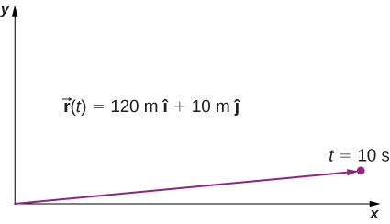

1. The position of a particle for *t* > 0 is given by  (a) What is the velocity as a function of time? (b) What is the acceleration as a function of time? (c) What is the particle’s velocity at *t* = 2.0 s? (d) What is its speed at *t* = 1.0 s and *t* = 3.0 s? (e) What is the average velocity between *t* = 1.0 s and *t* = 2.0 s?

Solution

a.  ,

b. , c. ,

d. 

 ,

e. 



1. The acceleration of a particle is a constant. At *t* = 0 the velocity of the particle is  At *t* = 4 s the velocity is  (a) What is the particle’s acceleration? (b) How do the position and velocity vary with time? Assume the particle is initially at the origin.

Solution

a. ,

b. 



1. A particle has a position function , where the arguments of the cosine and sine functions are in radians. (a) What is the velocity vector? (b) What is the acceleration vector?

Solution

a. , b. 

1. A Lockheed Martin F-35 II Lightning jet takes off from an aircraft carrier with a runway length of 90 m and a takeoff speed 70 m/s at the end of the runway. Jets are catapulted into airspace from the deck of an aircraft carrier with two sources of propulsion: the jet propulsion and the catapult. At the point of leaving the deck of the aircraft carrier, the F-35’s acceleration decreases to a constant acceleration of  at  with respect to the horizontal. (a) What is the initial acceleration of the F-35 on the deck of the aircraft carrier to make it airborne? (b) Write the position and velocity of the F-35 in unit vector notation from the point it leaves the deck of the aircraft carrier. (c) At what altitude is the fighter 5.0 s after it leaves the deck of the aircraft carrier? (d) What is its velocity and speed at this time? (e) How far has it traveled horizontally?

Solution

a. ,

b. 



,

c. ,

d. 



 ,

e. 

1. A bullet is shot horizontally from shoulder height (1.5 m) with an initial speed 200 m/s. (a) How much time elapses before the bullet hits the ground? (b) How far does the bullet travel horizontally?

Solution

a. , b. 

1. A marble rolls off a tabletop 1.0 m high and hits the floor at a point 3.0 m away from the table’s edge in the horizontal direction. (a) How long is the marble in the air? (b) What is the speed of the marble when it leaves the table’s edge? (c) What is its speed when it hits the floor?

Solution

a. , b. , c. 

1. A dart is thrown horizontally at a speed of 10 m/s at the bull’s-eye of a dartboard 2.4 m away, as in the following figure. (a) How far below the intended target does the dart hit? (b) What does your answer tell you about how proficient dart players throw their darts?

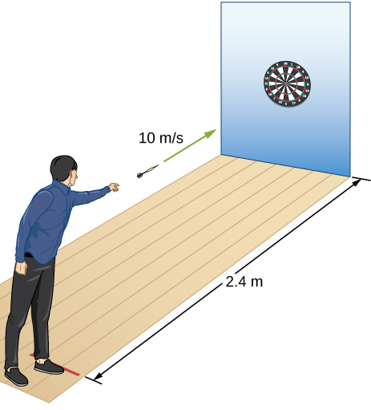

Solution

a. , b. They aim high.

1. An airplane flying horizontally with a speed of 500 km/h at a height of 800 m drops a crate of supplies (see the following figure). If the parachute fails to open, how far in front of the release point does the crate hit the ground?

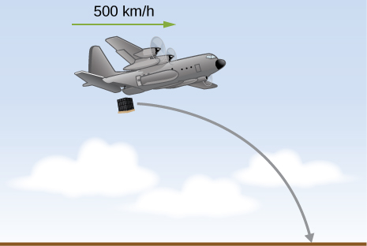

Solution

500.0 km/h = 139.0 m/s

1. Suppose the airplane in the preceding problem fires a projectile horizontally in its direction of motion at a speed of 300 m/s relative to the plane. )a) How far in front of the release point does the projectile hit the ground? (b) What is its speed when it hits the ground?

Solution

a., 

b. 

1. A fastball pitcher can throw a baseball at a speed of 40 m/s (90 mi/h). (a) Assuming the pitcher can release the ball 16.7 m from home plate so the ball is moving horizontally, how long does it take the ball to reach home plate? (b) How far does the ball drop between the pitcher’s hand and home plate?

Solution

a. , b. 

1. A projectile is launched at an angle of  and lands 20 s later at the same height as it was launched. (a) What is the initial speed of the projectile? (b) What is the maximum altitude? (c) What is the range? (d) Calculate the displacement from the point of launch to the position on its trajectory at 15 s.

Solution

a.  ,

b. ,

c. 

d. 

1. A basketball player shoots toward a basket 6.1 m away and 3.0 m above the floor. If the ball is released 1.8 m above the floor at an angle of  above the horizontal, what must the initial speed be if it were to go through the basket?

Solution







1. At a particular instant, a hot air balloon is 100 m in the air and descending at a constant speed of 2.0 m/s. At this exact instant, a girl throws a ball horizontally, relative to herself, with an initial speed of 20 m/s. When she lands, where will she find the ball? Ignore air resistance.

Solution

  

1. A man on a motorcycle traveling at a uniform speed of 10 m/s throws an empty can straight upward relative to himself with an initial speed of 3.0 m/s. Find the equation of the trajectory as seen by a police officer on the side of the road. Assume the initial position of the can is the point where it is thrown. Ignore air resistance.

Solution



 

1. An athlete can jump a distance of 8.0 m in the broad jump. What is the maximum distance the athlete can jump on the Moon, where the gravitational acceleration is one-sixth that of Earth?

Solution



1. The maximum horizontal distance a boy can throw a ball is 50 m. Assume he can throw with the same initial speed at all angles. How high does he throw the ball when he throws it straight upward?

Solution





1. A rock is thrown off a cliff at an angle of with respect to the horizontal. The cliff is 100 m high. The initial speed of the rock is 30 m/s. (a) How high above the edge of the cliff does the rock rise? (b) How far has it moved horizontally when it is at maximum altitude? (c) How long after the release does it hit the ground? (d) What is the range of the rock? (e) What are the horizontal and vertical positions of the rock relative to the edge of the cliff at *t* = 2.0 s, *t* = 4.0 s, and *t* = 6.0 s?

Solution

a. ,

b., c.  , d. ,

e. 





1. Trying to escape his pursuers, a secret agent skis off a slope inclined at  below the horizontal at 60 km/h. To survive and land on the snow 100 m below, he must clear a gorge 60 m wide. Does he make it? Ignore air resistance.

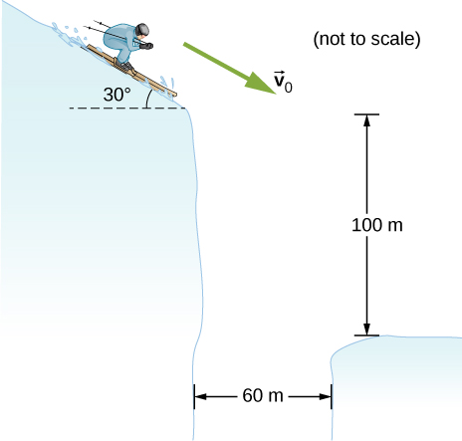

Solution





 



, so, no, the agent doesn’t make it.

1. A golfer on a fairway is 70 m away from the green, which sits below the level of the fairway by 20 m. If the golfer hits the ball at an angle of  with an initial speed of 20 m/s, how close to the green does she come?

Solution





So the golfer’s shot lands 13.3 m short of the green.

1. A projectile is shot at a hill, the base of which is 300 m away. The projectile is shot at  above the horizontal with an initial speed of 75 m/s. The hill can be approximated by a plane sloped at  to the horizontal. Relative to the coordinate system shown in the following figure, the equation of this straight line is  Where on the hill does the projectile land?

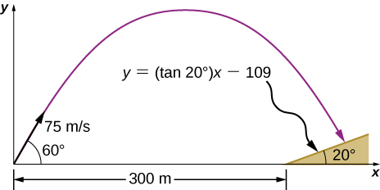

Solution

Equation of the trajectory of the projectile: 

Equation of the slope: 





1. An astronaut on Mars kicks a soccer ball at an angle of  with an initial velocity of 15 m/s. If the acceleration of gravity on Mars is 3.7 m/s2, (a) what is the range of the soccer kick on a flat surface? (b) What would be the range of the same kick on the Moon, where gravity is one-sixth that of Earth?

Solution

a. ,

b. 

1. Mike Powell holds the record for the long jump of 8.95 m, established in 1991. If he left the ground at an angle of what was his initial speed?

Solution



1. MIT’s robot cheetah can jump over obstacles 46 cm high and has speed of 12.0 km/h. (a) If the robot launches itself at an angle of  at this speed, what is its maximum height? (b) What would the launch angle have to be to reach a height of 46 cm?

Solution

a. 

,

b. 



1. Mt. Asama, Japan, is an active volcano. In 2009, an eruption threw solid volcanic rocks that landed 1 km horizontally from the crater. If the volcanic rocks were launched at an angle of  with respect to the horizontal and landed 900 m below the crater, (a) what would be their initial velocity and (b) what is their time of flight?

Solution

a. 

,

b. 

1. Drew Brees of the New Orleans Saints can throw a football 23.0 m/s (50 mph). If he angles the throw at  from the horizontal, what distance does it go if it is to be caught at the same elevation as it was thrown?

Solution



1. The Lunar Roving Vehicle used in NASA’s late *Apollo* missions reached an unofficial lunar land speed of 5.0 m/s by astronaut Eugene Cernan. If the rover was moving at this speed on a flat lunar surface and hit a small bump that projected it off the surface at an angle of  how long would it be “airborne” on the Moon?

Solution



1. A soccer goal is 2.44 m high. A player kicks the ball at a distance 10 m from the goal at an angle of  The ball hits the crossbar at the top of the goal. What is the initial speed of the soccer ball?

Solution





1. Olympus Mons on Mars is the largest volcano in the solar system, at a height of 25 km and with a radius of 312 km. If you are standing on the summit, with what initial velocity would you have to fire a projectile from a cannon horizontally to clear the volcano and land on the surface of Mars? Note that Mars has an acceleration of gravity of 

Solution

 

1. In 1999, Robbie Knievel was the first to jump the Grand Canyon on a motorcycle. At a narrow part of the canyon (69.0 m wide) and traveling 35.8 m/s off the takeoff ramp, he reached the other side. What was his launch angle?

Solution

Or 

1. You throw a baseball at an initial speed of 15.0 m/s at an angle of 30° with respect to the horizontal. What would the ball’s initial speed have to be at 30° on a planet that has twice the acceleration of gravity as Earth to achieve the same range? Consider launch and impact on a horizontal surface.

Solution



1. Aaron Rodgers throws a football at 20.0 m/s to his wide receiver, who is running straight down the field at 9.4 m/s. If Aaron throws the football when the wide receiver is 10.0 m in front of him, (a) at what angle does Aaron have to launch the ball so the ball will be at the same height as the receiver when the receiver makes it to 20.0 m in front of Aaron? (b) Will the receiver be able to catch the ball?

Solution

(a) It takes the wide receiver 1.1 s to cover the last 10 m of his run. 

(b) 

Therefore, the ball will be overthrown, and the receiver will not be able to catch it.

1. A flywheel is rotating at 30 rev/s. What is the total angle, in radians, through which a point on the flywheel rotates in 40 s?

Solution





1. A particle travels in a circle of radius 10 m at a constant speed of 20 m/s. What is the magnitude of the acceleration?

Solution



1. Cam Newton of the Carolina Panthers throws a perfect football spiral at 8.0 rev/s. The radius of a pro football is 8.5 cm at the middle of the short side. What is the centripetal acceleration of the laces on the football?

Solution

The period of one revolution is one-eighth of a second. The speed of the laces is 

1. A fairground ride spins its occupants inside a flying saucer-shaped container. If the horizontal circular path the riders follow has an 8.00-m radius, at how many revolutions per minute are the riders subjected to a centripetal acceleration equal to that of gravity?

Solution

 

 which is 

1. A runner taking part in the 200-m dash must run around the end of a track that has a circular arc with a radius of curvature of 30.0 m. The runner starts the race at a constant speed. If she completes the 200-m dash in 23.2 s and runs at constant speed throughout the race, what is her centripetal acceleration as she runs the curved portion of the track?

Solution



1. What is the acceleration of Venus toward the Sun, assuming a circular orbit?

Solution

Venus is 108.2 million km from the Sun and has an orbital period of 0.6152 y.





1. An experimental jet rocket travels around Earth along its equator just above its surface. At what speed must the jet travel if the magnitude of its acceleration is *g*?

Solution



1. A fan is rotating at a constant 360.0 rev/min. What is the magnitude of the acceleration of a point on one of its blades 10.0 cm from the axis of rotation?

Solution



 

1. A point located on the second hand of a large clock has a radial acceleration of 0.1 cm/s2. How far is the point from the axis of rotation of the second hand?

Solution



1. The coordinate axes of the reference frame  remain parallel to those of *S*, asmoves away from *S* at a constant velocity  (a) If at time *t* = 0 the origins coincide, what is the position of the origin  in the *S* frame as a function of time? (b) How is particle position for  and  as measured in *S* and  respectively, related? (c) What is the relationship between particle velocities  (d) How are accelerations  related?

Solution

a. ,

b.  ,

c. , d. The accelerations are the same.

1. The coordinate axes of the reference frame  remain parallel to those of *S*, as moves away from *S* with velocity  =  m/s. (a) If at time *t* = 0 the origins coincide, what is the position of origin  in the *S* frame as a function of time? (b) How is particle position for  and , as measured in *S* and  respectively, related? (c) What is the relationship between particle velocities  (d) How are accelerations  related?

Solution

a. ,

b. ,

c. , d. 

1. The velocity of a particle in reference frame *A* is  The velocity of reference frame *A* with respect to reference frame *B* is  and the velocity of reference frame *B* with respect to *C* is  What is the velocity of the particle in reference frame *C*?

Solution



1. Raindrops fall vertically at 4.5 m/s relative to the earth. What does an observer in a car moving at 22.0 m/s in a straight line measure as the velocity of the raindrops?

Solution

R = raindrops, C = car, G = ground





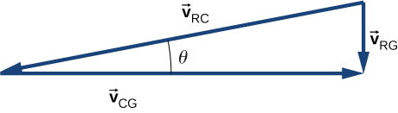

    
  The rain is coming from 11.3 degrees north of east

1. A seagull can fly at a velocity of 9.00 m/s in still air. (a) If it takes the bird 20.0 min to travel 6.00 km straight into an oncoming wind, what is the velocity of the wind? (b) If the bird turns around and flies with the wind, how long will it take the bird to return 6.00 km?

Solution

a. A = air, S = seagull, G = ground   
 velocity of seagull with respect to still air

 



b. 



1. A ship sets sail from Rotterdam, heading due north at 7.00 m/s relative to the water. The local ocean current is 1.50 m/s in a direction  north of east. What is the velocity of the ship relative to Earth?

Solution

S = ship, W = water, E = Earth

 

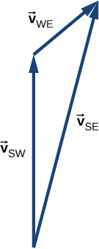

north of east]

1. A boat can be rowed at 8.0 km/h in still water. (a) How much time is required to row 1.5 km downstream in a river moving 3.0 km/h relative to the shore? (b) How much time is required for the return trip? (c) In what direction must the boat be aimed to row straight across the river? (d) Suppose the river is 0.8 km wide. What is the velocity of the boat with respect to Earth and how much time is required to get to the opposite shore? (e) Suppose, instead, the boat is aimed straight across the river. How much time is required to get across and how far downstream is the boat when it reaches the opposite shore?

Solution

Take the positive direction to be the same direction that the river is flowing, which is east. S = shore/Earth, W = water, and B = boat.

a.  



b.  



c.   west of north

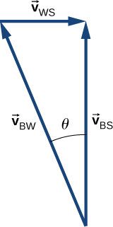

d.  

e.   but only the component of the velocity straight across the river is used to get the time

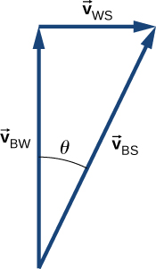



Downstream = 

1. A small plane flies at 200 km/h in still air. If the wind blows directly out of the west at 50 km/h, (a) in what direction must the pilot head her plane to move directly north across land and (b) how long does it take her to reach a point 300 km directly north of her starting point?

Solution

a. The pilot must direct her plane at an angle west of north to compensate for the wind.

 



The geometry of the velocity vectors is shown in the sketch.

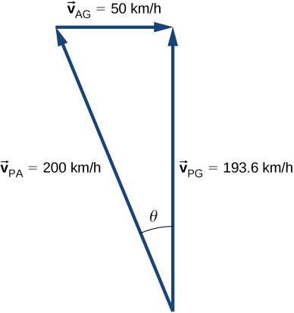

 

b. 

1. A cyclist traveling southeast along a road at 15 km/h feels a wind blowing from the southwest at 25 km/h. To a stationary observer, what are the speed and direction of the wind?

Solution



 

The angle between  and  is  so the direction of the wind is  north of east.

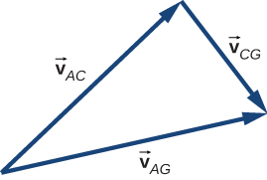

1. A river is moving east at 4 m/s. A boat starts from the dock heading  north of west at 7 m/s. If the river is 1800 m wide, (a) what is the velocity of the boat with respect to Earth and (b) how long does it take the boat to cross the river?

Solution

a.  



Velocity of the boat with respect to Earth is 4.03 m/s,  west of north.

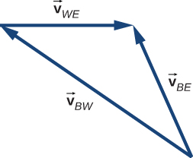

b. Using the *y-*component of the boat’s velocity with respect to Earth:

 8 min 34 s

**Additional Problems**

1. A Formula One race car is traveling at 89.0 m/s along a straight track enters a turn on the race track with radius of curvature of 200.0 m. What centripetal acceleration must the car have to stay on the track?

Solution



1. A particle travels in a circular orbit of radius 10 m. Its speed is changing at a rate of 15.0 m/s2 at an instant when its speed is 40.0 m/s. What is the magnitude of the acceleration of the particle?

Solution



1. The driver of a car moving at 90.0 km/h presses down on the brake as the car enters a circular curve of radius 150.0 m. If the speed of the car is decreasing at a rate of 9.0 km/h each second, what is the magnitude of the acceleration of the car at the instant its speed is 60.0 km/h?

Solution

 



1. A race car entering the curved part of the track at the Daytona 500 drops its speed from 85.0 m/s to 80.0 m/s in 2.0 s. If the radius of the curved part of the track is 316.0 m, calculate the total acceleration of the race car at the beginning and ending of reduction of speed.

Solution

The tangential acceleration is 

Beginning: 

Ending: 

1. An elephant is located on Earth’s surface at a latitude  Calculate the centripetal acceleration of the elephant resulting from the rotation of Earth around its polar axis. Express your answer in terms of  the radius  of Earth, and time *T* for one rotation of Earth. Compare your answer with *g* for 

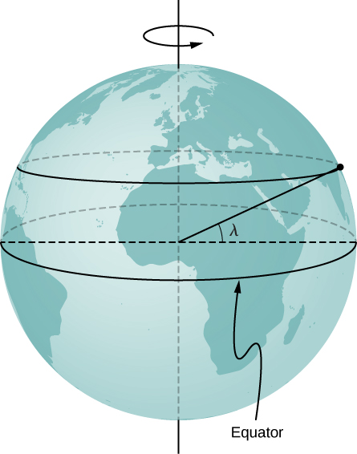

Solution

The radius of the circle of revolution at latitude  is  The velocity of the body is  for 

1. A proton in a synchrotron is moving in a circle of radius 1 km and increasing its speed by  (a) What is the proton’s total acceleration at *t* = 5.0 s? (b) At what time does the expression for the velocity become unphysical?

Solution

a. 





The total acceleration is nearly perpendicular to the direction of motion of the proton.

b. Velocities cannot exceed the speed of light. The speed of light is  but the proton would be relativistic before this time and our description would break down.

1. A propeller blade at rest starts to rotate from *t* = 0 s to *t* = 5.0 s with a tangential acceleration of the tip of the blade at  The tip of the blade is 1.5 m from the axis of rotation. At *t* = 5.0 s, what is the total acceleration of the tip of the blade?

Solution



 with respect to the tangent to the circle of revolution directed inward. 

1. A particle is executing circular motion with a constant angular frequency of  If time *t* = 0 corresponds to the position of the particle being located at *y* = 0 m and *x* = 5 m, (a) what is the position of the particle at *t* = 10 s? (b) What is its velocity at this time? (c) What is its acceleration?

Solution

a. 

b. 



c. 



1. A particle’s centripetal acceleration is at *t* = 0 s where it is on the *x*-axis and moving counterclockwise in the *xy* plane. It is executing uniform circular motion about an axis at a distance of 5.0 m. What is its velocity at *t* = 10 s?

Solution







1. A rod 3.0 m in length is rotating at 2.0 rev/s about an axis at one end. Compare the centripetal accelerations at radii of (a) 1.0 m, (b) 2.0 m, and (c) 3.0 m.

Solution

a. ,

b. 

c. 

1. A particle located initially at  undergoes a displacement of  What is the final position of the particle?

Solution



1. The position of a particle is given by  (a) What are the particle’s velocity and acceleration as functions of time? (b) What are the initial conditions to produce the motion?

Solution

a. 

b. The object has an initial *x*-component of the velocity of 5.0 m/s and accelerates downward at 9.8 m/s2.

1. A spaceship is traveling at a constant velocity of  when its rockets fire, giving it an acceleration of  What is its velocity  s after the rockets fire?

Solution







1. A crossbow is aimed horizontally at a target 40 m away. The arrow hits 30 cm below the spot at which it was aimed. What is the initial velocity of the arrow?

Solution



1. A long jumper can jump a distance of 8.0 m when he takes off at an angle of  with respect to the horizontal. Assuming he can jump with the same initial speed at all angles, how much distance does he lose by taking off at 

Solution



1. On planet Arcon, the maximum horizontal range of a projectile launched at 10 m/s is 20 m. What is the acceleration of gravity on this planet?

Solution



1. A mountain biker encounters a jump on a race course that sends him into the air at  to the horizontal. If he lands at a horizontal distance of 45.0 m and 20 m below his launch point, what is his initial speed?

Solution



1. Which has the greater centripetal acceleration, a car with a speed of 15.0 m/s along a circular track of radius 100.0 m or a car with a speed of 12.0 m/s along a circular track of radius 75.0 m?

Solution



The first car has the greater centripetal acceleration.

1. A geosynchronous satellite orbits Earth at a distance of 42,250.0 km and has a period of 1 day. What is the centripetal acceleration of the satellite?

Solution





1. Two speedboats are traveling at the same speed relative to the water in opposite directions in a moving river. An observer on the riverbank sees the boats moving at 4.0 m/s and 5.0 m/s. (a) What is the speed of the boats relative to the river? (b) How fast is the river moving relative to the shore?

Solution

Label the two boats 

a.   

  ,

b. 

**Challenge Problems**

1. World’s Longest Par 3. The tee of the world’s longest par 3 sits atop South Africa’s Hanglip Mountain at 400.0 m above the green and can only be reached by helicopter. The horizontal distance to the green is 359.0 m. Neglect air resistance and answer the following questions. (a) If a golfer launches a shot that is with respect to the horizontal, what initial velocity must she give the ball? (b) What is the time to reach the green?

Solution

a. 



, b. 

1. When a field goal kicker kicks a football as hard as he can at  to the horizontal, the ball just clears the 3-m-high crossbar of the goalposts 45.7 m away. (a) What is the maximum speed the kicker can impart to the football? (b) In addition to clearing the crossbar, the football must be high enough in the air early during its flight to clear the reach of the onrushing defensive lineman. If the lineman is 4.6 m away and has a vertical reach of 2.5 m, can he block the 45.7-m field goal attempt? (c) What if the lineman is 1.0 m away?

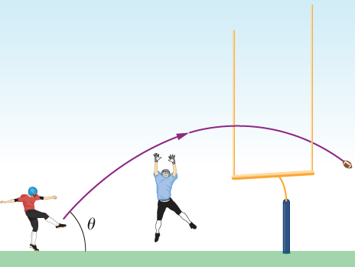

Solution

a. 



,

b. 

No, he will not block the field goal attempt.

c. 

Yes, he will block the attempt.

1. A truck is traveling east at 80 km/h. At an intersection 32 km ahead, a car is traveling north at 50 km/h. (a) How long after this moment will the vehicles be closest to each other? (b) How far apart will they be at that point?

Solution

a. 



,

b. 

This file is copyright 2016, Rice University. All Rights Reserved.